Costume Barn

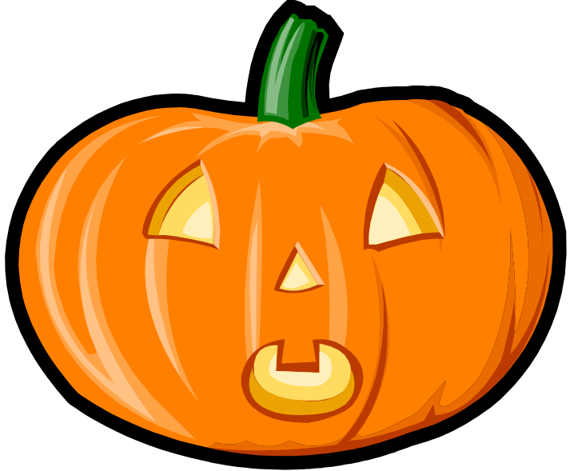

THE Costume Shop!
(317) 555-0826
Costume barn is a one-stop Halloween shoppers' paradise. We offer a huge selection of Halloween merchandise. We stock a complete line of high-quality costumes, masks, make-up, and accessories for adults, teens, and children at unbeatable prices.
Sample Price List
 |  | Adult | Teen | Child
Vampires | Costume | 30.99 | 18.99 | 15.99
Vampires | Accessories | 17.99 | 15.99 | 8.99
Vampires | Total | 48.98 | 34.98 | 24.98
Jester | Costume | 21.99 | 14.99 | 13.99
Jester | Accessories | 14.99 | 12.99 | 8.99
Jester | Total | 36.98 | 27.98 | 22.98
Costumes and Accessories are sold separately. For example, the vampire costume consists of a one-piece, black suit with attached cape. The accessories include as black wig, white gloves, fangs, and make-up. Customer barn provides you with:
- Courteous, knowledgeable sales staff
- Make-up tips
- 15 years costuming experience
Costume barn has supplied the best costumes and accessories from our same location 22 acorn avenue, Indianapolis, Indiana, for more than twenty years. Let us outfit you this Halloween. Stop by and see us or place your order by telephone by calling us at 37-555-0826

